User Guide

How to Start the System

First thing you have to of course is install a recent version of Microsoft Visual Studio. From there, you have to access the code of the game. Once you have it open you can run the code which will open up a seperate window, said window contains the game. Make the window full screen and there you will get the title screen and are ready to play.

How to use different features of the system

Your main way of interacting with the game will be through select keys. You start the game by hitting enter and then all of the controls will pop up for you. For clarification, you will mostly be using 1, 2, 3 and 4 and hitting enter to confirm your choice. Alongside those, you will sometimes hit other keys to access the other functions. You can hit ‘I’ to open the inventory, ‘O’ to open the player overview, and ‘Q’ to quit the inventory menu. Those are all of the ways that the player can interact with the game.

Screenshots explaining main features of the system

Controls and Introduction to the game

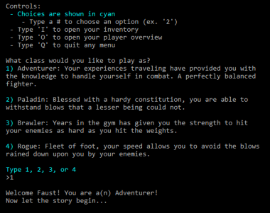

**NEXT PAGE**

Decision Making System

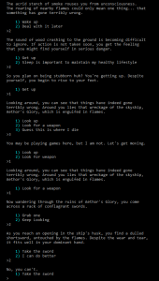

Battle/Combat

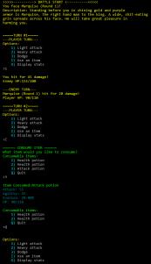

Inventory and Items in Combat

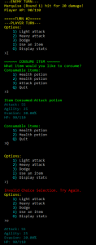

Input & Output

The input for this game is the controls that I specifically mentioned earlier. The output is the text that is delivered in reaction to the player’s decisions. The color of the text differs depending on what is being delivered on screen. White text is descriptions and dialogue. Yellow is combat. Green is for when accessing the inventory and red is for an ivalid choice. Overall the amount of inputs and outputs are not extremely complicated.